Chapter 6:

Synthesis and future directions

Ellen van Velzen
In recent years, interest in the interplay between ecological and evolutionary dynamics has grown dramatically, as it has become increasingly clear that feedbacks between ecological and evolutionary processes can affect biological systems in complex and sometimes unpredictable ways (Fagerstrom et al. 1987; Johnson and Stinchcombe 2007; Kokko and Lopez-Sepulcre 2007; Pelletier et al. 2009; Post and Palkovacs 2009; Schoener 2011). Recent studies on eco-evolutionary dynamics range from the relatively small-scale, such as predator-prey dynamics in simple systems (Yoshida et al. 2003; Yoshida et al. 2007) to complex communities and ecosystem functioning (Harmon et al. 2009; Palkovacs et al. 2009; Seehausen 2009; Bassar et al. 2010). Eco-evolutionary perspectives have been used to study important issues in ecology and evolution, such as evolutionary divergence and speciation (Harmon et al. 2009; Seehausen 2009) and coexistence (Egas et al. 2004; Abrams 2006a; Kremer and Klausmeier 2013), sometimes with contradictory results.
This thesis is centered around two major themes: first, the coexistence of competitors on shared resources or with shared predators; and second, their evolutionary emergence through ecological speciation (evolutionary branching), with a particular emphasis on the joint effects of ecology and evolution. Most recent research into eco-evolutionary dynamics focuses on the effects of rapid evolution (Hairston et al. 2005; Carroll et al. 2007; Hendry et al. 2007; Lankau 2011); in this thesis I used simulations to model evolutionary and ecological processes taking place simultaneously, relaxing the traditional modelling assumption of separate time-scales, but generally still assumed evolution is slower than ecology. Despite this, the results in this thesis show interesting interactions between ecological and evolutionary dynamics.

Eco-evolutionary dynamics
For eco-evolutionary feedbacks to occur, two conditions must be met: first, ecological interactions (with competitors, species on other trophic levels, or the environment) must drive evolutionary change; and second, this evolutionary change must affect the original ecological interactions, thus closing the feedback loop (Post and Palkovacs 2009). Both processes have been observed in the models in this thesis.
Ecology affects evolution
This thesis has focussed largely on competitive interactions, which have a major effect on evolution in all models considered. I studied at the effects of competition in a number of different context: the presence of them at all in a lower trophic level (Chapter 2); the symmetry / asymmetry of competition (Chapter 3); and the severity of competition and the life stage at which competition plays out (Chapter 5). Of course, in addition to competition, evolution is affected by interactions with higher or lower trophic levels, for example the abundance of resources or consumers (Chapter 2, Chapter 3).
In a plant-herbivore system, competition between plants can affect herbivore evolution (Chapter 2). The most obvious effect is that competition (especially when coupled with asymmetric consumption of the two plants) affects the relative abundances of the two plants; but more importantly, it drives fluctuations in plant abundance, which dramatically changes the fitness landscape for the herbivores, in turn driving the evolution of specialization.
In the context of plant evolution, I also showed a major effect of competition between plants (Chapter 3). Specifically, whether or not defense could lead to asymmetric competition (through affecting a plant’s competitiveness rather than, or in addition to, its growth rate) determines whether evolutionary branching into different defense strategies can occur. Moreover, in this model a second ecological factor has a major effect on evolution: whether the plant is defending against a generalist or a specialist herbivore. Not only can this affect the level of defense that evolves (investment in defense is often lower against specialist herbivores), but evolutionary branching is only possible when defending against generalist herbivores.
Finally, in host-parasitoid systems, the evolution of host preference is driven mainly by the level of within-host competition among parasitoids (a compound of the level of intraspecific aggregation and the within-host carrying capacity) (Chapter 5). Severe within-host competition invariably leads to a preference for unparasitized hosts, but this preference largely disappears as the within-host carrying capacity increases. Most importantly, evolutionary branching is only possible when the within-host carrying capacity is high.
Evolution affects ecology, and eco-evolutionary feedbacks
The converse, evolution affecting ecology, also occurred in the models studied in this thesis: evolutionary change affects plant and herbivore abundances (Chapter 2, Chapter 3), generates eco-evolutionary cycles (Chapter 2, Chapter 3) and makes coexistence possible in host-parasitoid systems (Chapter 4, Chapter 5).
The evolution of plant preference in herbivores has a distinct effect on the ecological plant-herbivore dynamics (Chapter 2). As herbivores evolve, consumption of the two plant species changes, which in turn affects the relative abundances of the plants. In addition, the level of specialization of the herbivores affects how strongly plants and herbivores interact, and this in turn can affect population dynamics: specialist herbivores drive larger fluctuations in plant abundance than generalist herbivores. These patterns of abundance then determine the fitness landscape for the herbivores, causing eco-evolutionary feedbacks. This feedback between ecology and evolution can lead to several different types of evolutionary cycling, as the evolution of a new (often more generalist) herbivore changes the fitness landscape in such a way that at least one herbivore strategy becomes non-viable. For example, as the herbivores evolve into two specialists leading to stronger fluctuations in abundance, the advantage of generalism increases, allowing a more generalist strategy to evolve; the presence of a generalist then dampens the fluctuations, causing the generalist to lose its selective advantage and go extinct, leaving the two specialists, after which the cycle starts again. This eco-evolutionary cycle is similar to that found by Yamamichi et al (Yamamichi et al. 2011), who modelled the coexistence of a phenotypically plastic generalist with two specialists.
Similar eco-evolutionary cycling is found when considering plant evolution (Chapter 3). This is what causes the major difference between defending against generalist and specialist herbivores: specialist herbivores are dependent on a single plant species and their abundance is strongly affected by evolution of defense, whereas this is not the case for generalists. Thus, plant evolution can feed back on herbivore abundance; and as herbivore pressure changes, so does selection on defense, causing eco-evolutionary cycles similar to the classic experiment of Yoshida et al (Yoshida et al. 2003). A second type of eco-evolutionary cycling occurs when disruptive selection causes evolutionary branching: herbivore abundance increases rapidly as less-defended plants evolve, driving these plants extinct and leaving just the well-defended plants, causing herbivore abundance to drop again and defense to evolve back to lower values. Interestingly, this means that eco-evolutionary feedback in this case impairs evolutionary branching and coexistence.
Coexistence is also affected by parasitoid evolution in a host-parasitoid system. Evolutionary divergence in parasitization strategies (preference for unparasitized / parasitized hosts) allows coexistence of two parasitoid species under conditions where this is not possible for non-diverged species (low within-host competition and complete distribution overlap, Chapter 4). Given these earlier results on coexistence, it was somewhat surprising to see evolutionary branching in Chapter 5 under the exact conditions that inhibit coexistence in a purely ecological model. Evolutionary divergence in this case appears to allow coexistence by decreasing competition between the two strategies (see (Lankau 2011)); paradoxically, the two strategies sharing the same hosts is necessary for branching to occur at all, as females following the superparasitizing strategy depend on hosts already parasitized by the other (superparasitism-avoiding) strategy. Intriguingly, this means that evolution changes the interaction between the two competing parasitization strategies from purely competitive to at least partly facilitative.
This suggests that not only can evolutionary change affect the strength of ecological interactions, but it can fundamentally change the nature of the interaction altogether. The role of evolution in shaping and changing interactions is an intriguing one, and the possibility of facilitation evolving from competitive interactions especially remains poorly studied (Bronstein 2009), even though facilitation has been implicated as an important driver of biodiversity (McIntire and Fajardo 2014). In Chapter 5, facilitation arose as an emergent property in a model consisting only of explicitly modelled competitive interactions, giving one more example of how the outcome of evolution in an eco-evolutionary context can be difficult to predict.

Coexistence: costs and trade-offs
In the context of coexistence between competitors on two resources (e.g. habitats or prey species), the shape of the trade-off in using the two resources has a long history of being used to explain coexistence. The classic model of habitat use by Levins (Levins 1962) predicted that a weak (convex) trade-off led to a single generalist strategy, whereas a strong (concave) trade-off led to coexistence of two specialists. This general result has been confirmed in many models: habitat specialization (Egas et al. 2004), consumer specialization on two resources (Abrams 2006a; Abrams 2006b), or the coexistence of fast-growing opportunist species with strong resource competitors (Kremer and Klausmeier 2013). My results on herbivore specialization (Chapter 2) are consistent with these general results: evolutionary branching in plant consumption is only possible for a strong trade-off.
Similarly, several studies have found that a concave trade-off can enable the coexistence of defense strategies, the scenario studied in Chapter 3. In a host-parasite model where hosts can evolve resistance against parasites, a convex trade-off between resistance and growth rate always led to a single ESS level of resistance, while a concave trade-off gave rise to evolutionary branching (Bowers and Hodgkinson 2001). In a microbial food web model with a trade-off between defense and growth, Vage et al (Vage et al. 2014) again found coexistence only for a concave trade-off. However, in my model of defense against herbivory in plants, no such relationship between trade-off shape and coexistence was found (Chapter 3). A direct trade-off between defense and growth rate, whether linear, convex or concave, always gave rise to a single ESS; to get evolutionary branching or coexistence, a trade-off between defense and a different trait (competitiveness) was required.
This last result is consistent with some previous studies that compare trade-offs between traits, sometimes finding major differences between different trade-off structures. In the evolution of resistance against parasites (Bowers and Hodgkinson 2001), a concave trade-off only leads to evolutionary branching if the trade-off is between resistance and intrinsic growth rate; a trade-off between resistance to parasites and resistance to crowding gave the exact opposite result (convex trade-offs leading to branching, while concave trade-offs gave rise to a single ESS). Similarly, Egas et al (Egas et al. 2004), studying habitat specialization using a two-habitat model, found that the probability of coexistence strongly depended on whether the trade-off for using the two habitats affected the intrinsic growth rate or the carrying capacity, with coexistence being much more likely in the latter case.
While the trade-off shape has received a lot of attention from theoretical models, the role of the trade-off structure has been far less well studied; as one striking example, models on plant defense universally use a trade-off between defense and growth rate, while many other trade-offs are possible (Strauss et al. 2002). The results of Chapter 2 and Chapter 3 show that while the trade-off shape can be an important explanatory factor in some ecological scenarios, this is not universally the case; and the role of the traits affected by the trade-off deserves far more attention than it has received so far.

Future directions: herbivore and plant evolution
Although the research in this thesis has given some new insights into eco-evolutionary dynamics in various consumer-resource systems, other questions are still left wide open and some new questions arise. Below, I describe several directions for future research, along with some preliminary results to give some indication of where these directions could lead.
6.1. The speed of evolution vs. ecological dynamics in herbivore specialization
In the context of eco-evolutionary dynamics, the relative speed of ecological and evolutionary dynamics can play a major part in determining the outcome. Several studies have found that slow evolution promotes coexistence of competitors, while fast evolution impairs it (e.g. for specialist-generalist coexistence, (Abrams 2006b); coexistence of growth / competition specialists on a fluctuating resource, (Kremer and Klausmeier 2013)). Moreover, fast evolution of predators and prey can destabilize predator-prey dynamics ((Abrams and Matsuda 1997)). On the other hand, terHorst et al (terHorst et al. 2010) found that fast evolution promotes coexistence, while Vasseur et al (Vasseur et al. 2011) found it can either stabilize or destabilize ecological dynamics, depending on the intraspecific and interspecific competition coefficients of the competing species.
Because the speed of evolution can have such large and diverse effects, I looked at the effect of varying the mutation rate on the evolution of herbivore specialization.

Preliminary results
Varying the mutation rate has a strong effect on herbivore evolution, particularly when the plant growth rate r is high (and fluctuations in plant abundance are therefore faster and have a larger amplitude) (Figure 6.1). For both fast-growing and slow-growing plants, increasing the mutation rate leads to more specialization, but the effect is most pronounced for fast-growing plants: when evolution is very slow (m = 0.001), a majority of simulation runs give rise to a single generalist, even when the trade-off is strong to very strong (n > 1.4). As the mutation rate increases, the other outcomes become more common, with the least generalism found for the highest mutation rate.
Additionally, all types of evolutionary cycling are more common as the mutation rate increases. As the majority of the new evolutionary outcomes found in Chapter 2 involved evolutionary cycling, this means that, as the speed of evolution becomes very slow relative to the speed of ecological dynamics, herbivore evolution becomes mostly restricted to the original three outcomes again (one generalist, two specialists, or one generalist with two specialists). The exception is the only non-cycling new outcome, one generalist with one specialist, which still occurs even if evolution is slow; but it may still disappear when evolution is slowed down even further.
In general, it appears that varying the speed of evolution can have a major impact on which types of herbivores can evolve, and whether evolution results in stable coexistence or branching / extinction cycles. However, these preliminary results raise new questions. While they certainly suggest that the speed of evolution can play a major role, the range of mutation rates studied is still very limited, leaving out both very slow and very fast evolution. Particularly the latter has been implicated in dramatically altering eco-evolutionary dynamics (Yoshida et al. 2003; Yoshida et al. 2007; Schoener 2011; Yamamichi et al. 2011); theoretical studies have predicted that it can either impair coexistence or promote it (Abrams 2006b; terHorst et al. 2010; Vasseur et al. 2011; Kremer and Klausmeier 2013). The preliminary results described here suggest that fast evolution leads more easily to branching / extinction cycles and, thus, to less stable coexistence in the long run.
A related factor I have not studied at all is the effect of varying the mutational step size. In all simulations I have used only mutations with small effect (drawing the new trait value from a normal distribution with σ = 0.01), allowing only gradual evolution. Allowing larger mutations can have a significant effect on evolutionary dynamics, particularly whether or not branching can take place (Ito and Dieckmann 2012; Sagitov et al. 2013); this may yet again change the outcome of herbivore evolution. Similar effects may be found by including immigration: if herbivores with a radically different strategy from those present in the population invades, it may allow coexistence of combinations of strategies that cannot be reached through gradual evolution (see e.g. (Kisdi 2002; Egas et al. 2004)). How all of these factors together may shape the eco-evolutionary dynamics is difficult to predict, and this is certainly a worthwhile avenue for further investigation.

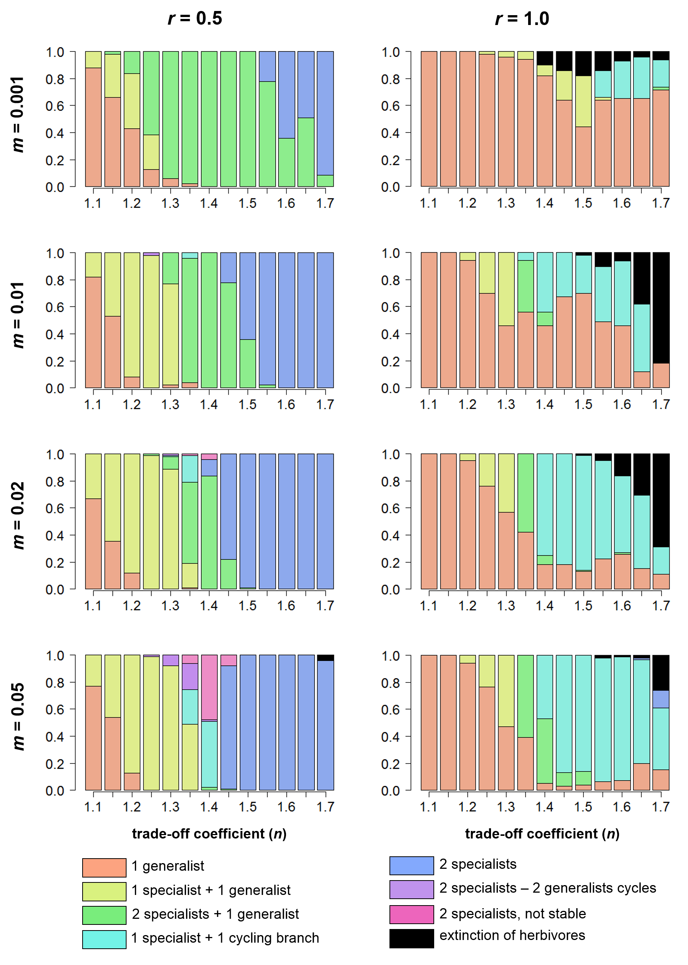
Figure 6.1. Outcomes of herbivore evolution for different mutation rates (m) and plant growth rates (r). Other parameter values: T = 4.5∙10⁶, c_{P} = 1.0, c_{H} = 2.0, a = 10⁻⁵, t_{h} = 0.1, e = 0.25, d_{P} = 0.05, d_{H} = 0.4; mutation step size = 0.01. Colours denote evolutionary outcomes, recorded after 100,000 time steps; each bar represents 50 simulation runs, except in the case of m = 0.05, where each bar represents 100 simulation runs.

6.2. Evolution of herbivore specialization on three plant species
Traditionally, models of specialization and generalist-specialist coexistence use a consumer-resource structure with two resources (Egas et al. 2004; Abrams 2006a; Abrams 2006b). While such simple models can give a lot of insight into fundamental questions – e.g. under what conditions generalists and specialists can evolve or coexist – their use is limited due to the very limited number of possible strategies that can be supported by two resources. Recent work has shown that more complex outcomes are possible when more realism or complexity is added to these models (e.g. behavioural responses, (Rueffler et al. 2007); competition between resources, this thesis, Chapter 2), but one extension that has, to my knowledge, not been studied is extending the model to more than two resources. The range of possible evolutionary scenarios and combinations of herbivore strategies increases exponentially as the number of resources increases, but which of these are possible, evolutionarily attainable or evolutionarily stable is an open question.
To study just one possible scenario, I simulated the evolution of herbivore preference on three plant species, modifying the simulation used in Chapter 2.
Preliminary results
Simulating herbivore preference in a three-plant system for only a limited parameter range for plant growth rate r and a single value for total nutrients T (intermediate, T = 4.5∙10⁶) results in a large diversity of different evolutionary outcomes (Figures 6.2, 6.3). Most of the general patterns found in the two-plant model are upheld here: the level of specialization depends on the severity of the trade-off (cost for generalism, n) and on plant intrinsic growth rate (r), with most specialization found for high n (strong trade-off) and low r (slow-growing plants). Extinction of herbivores is more common here than in the two-plant model, but again occurs mostly when the trade-off is strong to very strong (high n).
Apart from the extreme evolutionary outcomes (1 generalist and 3 specialists), eight in-between patterns of specialization are found. All of these include at least one herbivore that is partly-specialized, consuming 2 out of the 3 plant species available. Three evolutionary outcomes include only these herbivores (“2/3 generalists”, Figure 6.2, outcome 2-4); in two outcomes, they coexist with a generalist consuming all three plant species (Figure 6.2, outcome 5-6); and in the last three, they coexist with at least 1 complete specialist, consuming only one plant species (Figure 6.2, outcome 7-9). While many other combinations of generalists and specialists are imaginable, these are the only outcomes found in these simulations. I never found more than three herbivores coexisting on the three plant species, i.e. the number of herbivore strategies did not exceed the number of plants available, while this is not only possible but common in the two-plant model ((Abrams 2006a), this thesis, Chapter 2).
The most striking result, especially when comparing these results to those of the two-plant model, is that no branching / extinction cycles or other types of evolutionary cycling occurred at all. While the mutation rate used in these simulations was relatively low (m = 0.02; see the results of section 6.1 above), the same parameter values did generate evolutionary cycling in the two-plant model (see Figure 6.1).
This extended model with three plant species is clearly still a strongly simplified model, and does not itself give much insight into evolution in more realistic communities+ but it raises some intriguing possibilities and questions. Some of the patterns found in this pilot study strongly resemble those of the two-plant model (e.g. specialization increasing with a stronger trade-off), while others (particularly the lack of evolutionary cycling) are very different. I did not exhaustively explore all parameter ranges to determine whether evolutionary cycling can be found under other conditions, but these results suggest the interesting possibility that evolutionary cycling could be limited to the two-plant scenario only; although why this should be the case is unclear, and opens an interesting avenue for further study.
The same applies to the result that the number of herbivores coexisting can never exceed the number of plants: while it is unclear whether other parameter ranges could support more than three herbivore strategies, the fact that this did not occur even once in the parameter range I did explore is suggestive. If these major conclusions drawn from classic two-resource (in this case, two-plant) models really hinge on the two-resource assumption and do not hold up if this assumption is relaxed, we should be careful about drawing general conclusions from this type of simple model. But for which conclusions this is the case, and what would happen if the model is extended to even more plant species, is currently still an open question.
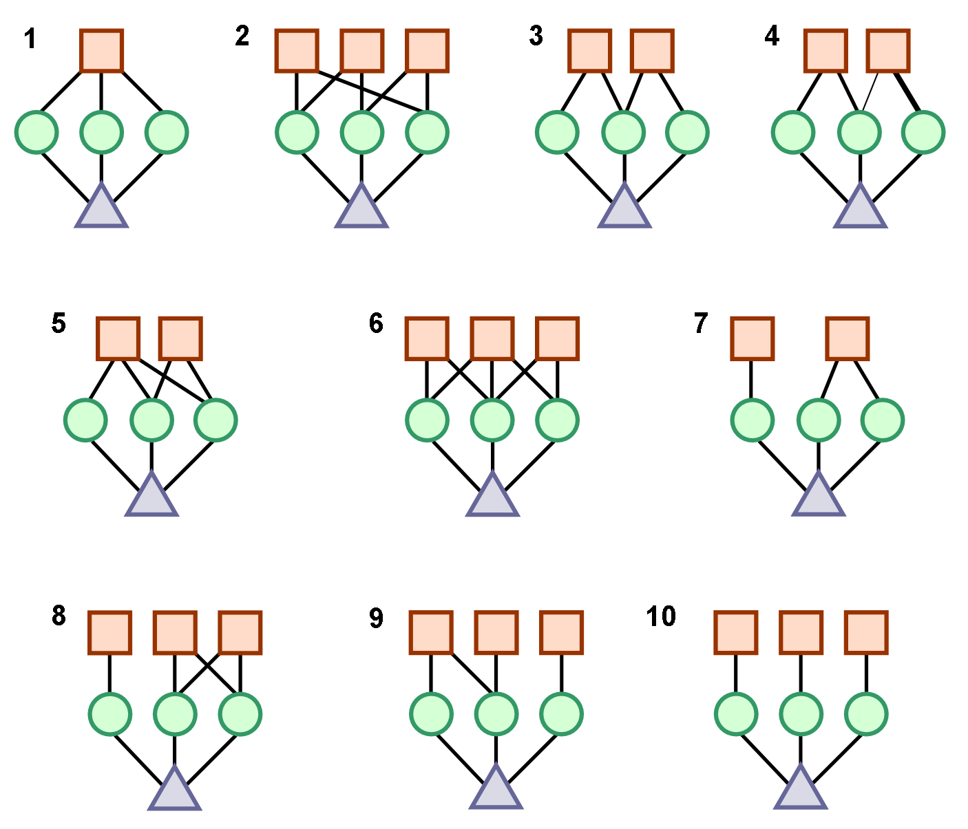
Figure 6.2. Patterns of specialization found in the three-species simulations. Herbivores are represented by squares, plants by circles, and nutrients by triangles. (1) 1 generalist. (2) 3 2/3 generalists (each consuming 2 of the 3 plant species). (3) 2 2/3 generalists. (4) 2 2/3 generalists, where one has a strong preference for a single plant species. (5) 1 generalist and 1 2/3 generalist. (6) 1 generalist and 2 2/3 generalists. (7) 1 specialist and 1 2/3 generalist. (8) 1 specialist and 2 2/3 generalists. (9) 2 specialists and 1 2/3 generalist. (10) 3 specialists.

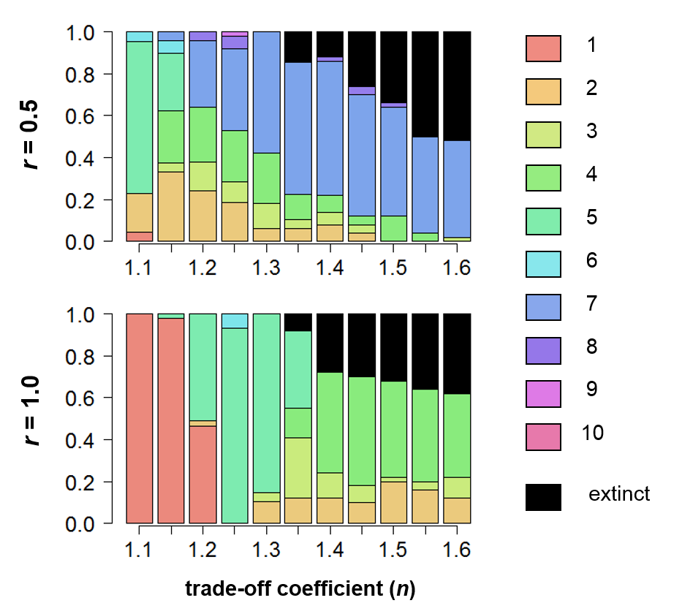
Figure 6.3. Herbivore specialization on 3 plants. Colours denote different evolutionary outcomes; numbers in the legend refer to the outcomes shown in Figure 6.2. Each bar represents 50 simulation runs, recorded after 100,000 time steps. Other parameters: T = 4.5∙10⁶, c_{P} = 1.0, c_{H} = 2.0, a = 10⁻⁵, t_{h} = 0.1, e = 0.25, d_{P} = 0.05, d_{H} = 0.4; mutation step size = 0.01; mutation rate = 0.02.

6.3. Plant-herbivore coevolution
Although the evolution of consumer specialization on two resources has been studied extensively ((Egas et al. 2004; Abrams 2006a; Abrams 2006b; Rueffler et al. 2007), this thesis, Chapter 2), and the same is true for the evolution of vulnerability to predation in prey sharing a predator (Abrams 2000; Abrams and Chen 2002; Abrams and Chen 2002), to our knowledge the effect of co-evolution between consumers and resources (e.g. predator and prey, herbivores and plants) has not been investigated. Some simpler models on plant-herbivore systems have shown that plant-herbivore co-evolution may have far more complex results than evolution in plants or herbivores alone. For example, Loeuille and Loreau (Loeuille and Loreau 2004) found that evolution in a single trophic level had straightforward eco-evolutionary effects, with two potential different outcomes at most; but when co-evolution was allowed, the number of possible outcomes in one model increased to 32. Because plant and herbivore evolution may interact in complex and unpredictable ways, this may be the single most important and interesting avenue for further research.
To get some idea of how plant-herbivore co-evolution would play out in this system, I combined the herbivore specialization model of Chapter 2 and the plant evolution model of Chapter 3, assuming a direct cost for evolution of defense in plants (decreasing growth rate). Herbivore evolution was simulated using the lineage-based simulation of Chapter 2, while plant evolution was added to this model in a fairly simple way. Each time step, one plant species was chosen at random and allowed to “mutate”: a new value for its investment into defense was drawn from a normal distribution around the current (resident) value, with a very small standard deviation (σ = 0.001). Its fitness and that of the resident were calculated as their net growth rate in the current herbivore population, and the strategy with the higher fitness was set as the new resident strategy.
Because I am here mostly interested in whether different herbivore strategies evolve under plant-herbivore coevolution, I chose a parameter range that includes all eight possible herbivore outcomes of Chapter 2 (T = 4.5∙10⁶; r = 0.5 – 1.0). Because evolution is modelled in very different ways on the plant and herbivore level, it is difficult to compare the rates of evolution on the two trophic levels, but with the parameters used, they appear to be on the same timescale (see Figure 6.6).
Preliminary results
Effects on herbivore evolution
The evolution of plant defense has a significant effect on herbivore evolution, especially for high plant intrinsic growth rate (Figure 6.4). The most noticeable result is that pure generalism almost entirely disappears, even for a relatively weak trade-off. The reason for this is that some level of defense always evolves against a single generalist herbivore, regardless of how plant and herbivore evolution proceed afterwards (see Figure 6.6). This has two effects: first, it decreases the plant growth rate (because defense is costly), dampening the fluctuations in plant abundance and decreasing the advantageous effect of generalism. Second, it decreases the quality of plants, increasing the advantage of specializing. These two effects together give enough of a disadvantage to generalists that some level of specialization almost always evolves for the parameter range studied (though not when the trade-off is convex (n < 1, results not shown)).
The second major effect is that plant evolution appears to stabilize the evolutionary dynamics of the herbivores, leading to less evolutionary cycling; one of the types of cycling (2 generalists – 2 specialists) disappears entirely, reducing the number of possible evolutionary outcomes. I found no new evolutionary patterns in any of the simulations.
For all growth rates, a lower cost of defense generally leads to a higher level of defense (Figure 6.5), subsequently leading to more specialization, though the difference in herbivore evolution is relatively small, especially for higher intrinsic growth rate (Figure 6.4, 6.5). It appears that including plant evolution at all is what causes the major differences in herbivore evolution, while the level of defense that evolves plays a much smaller role.

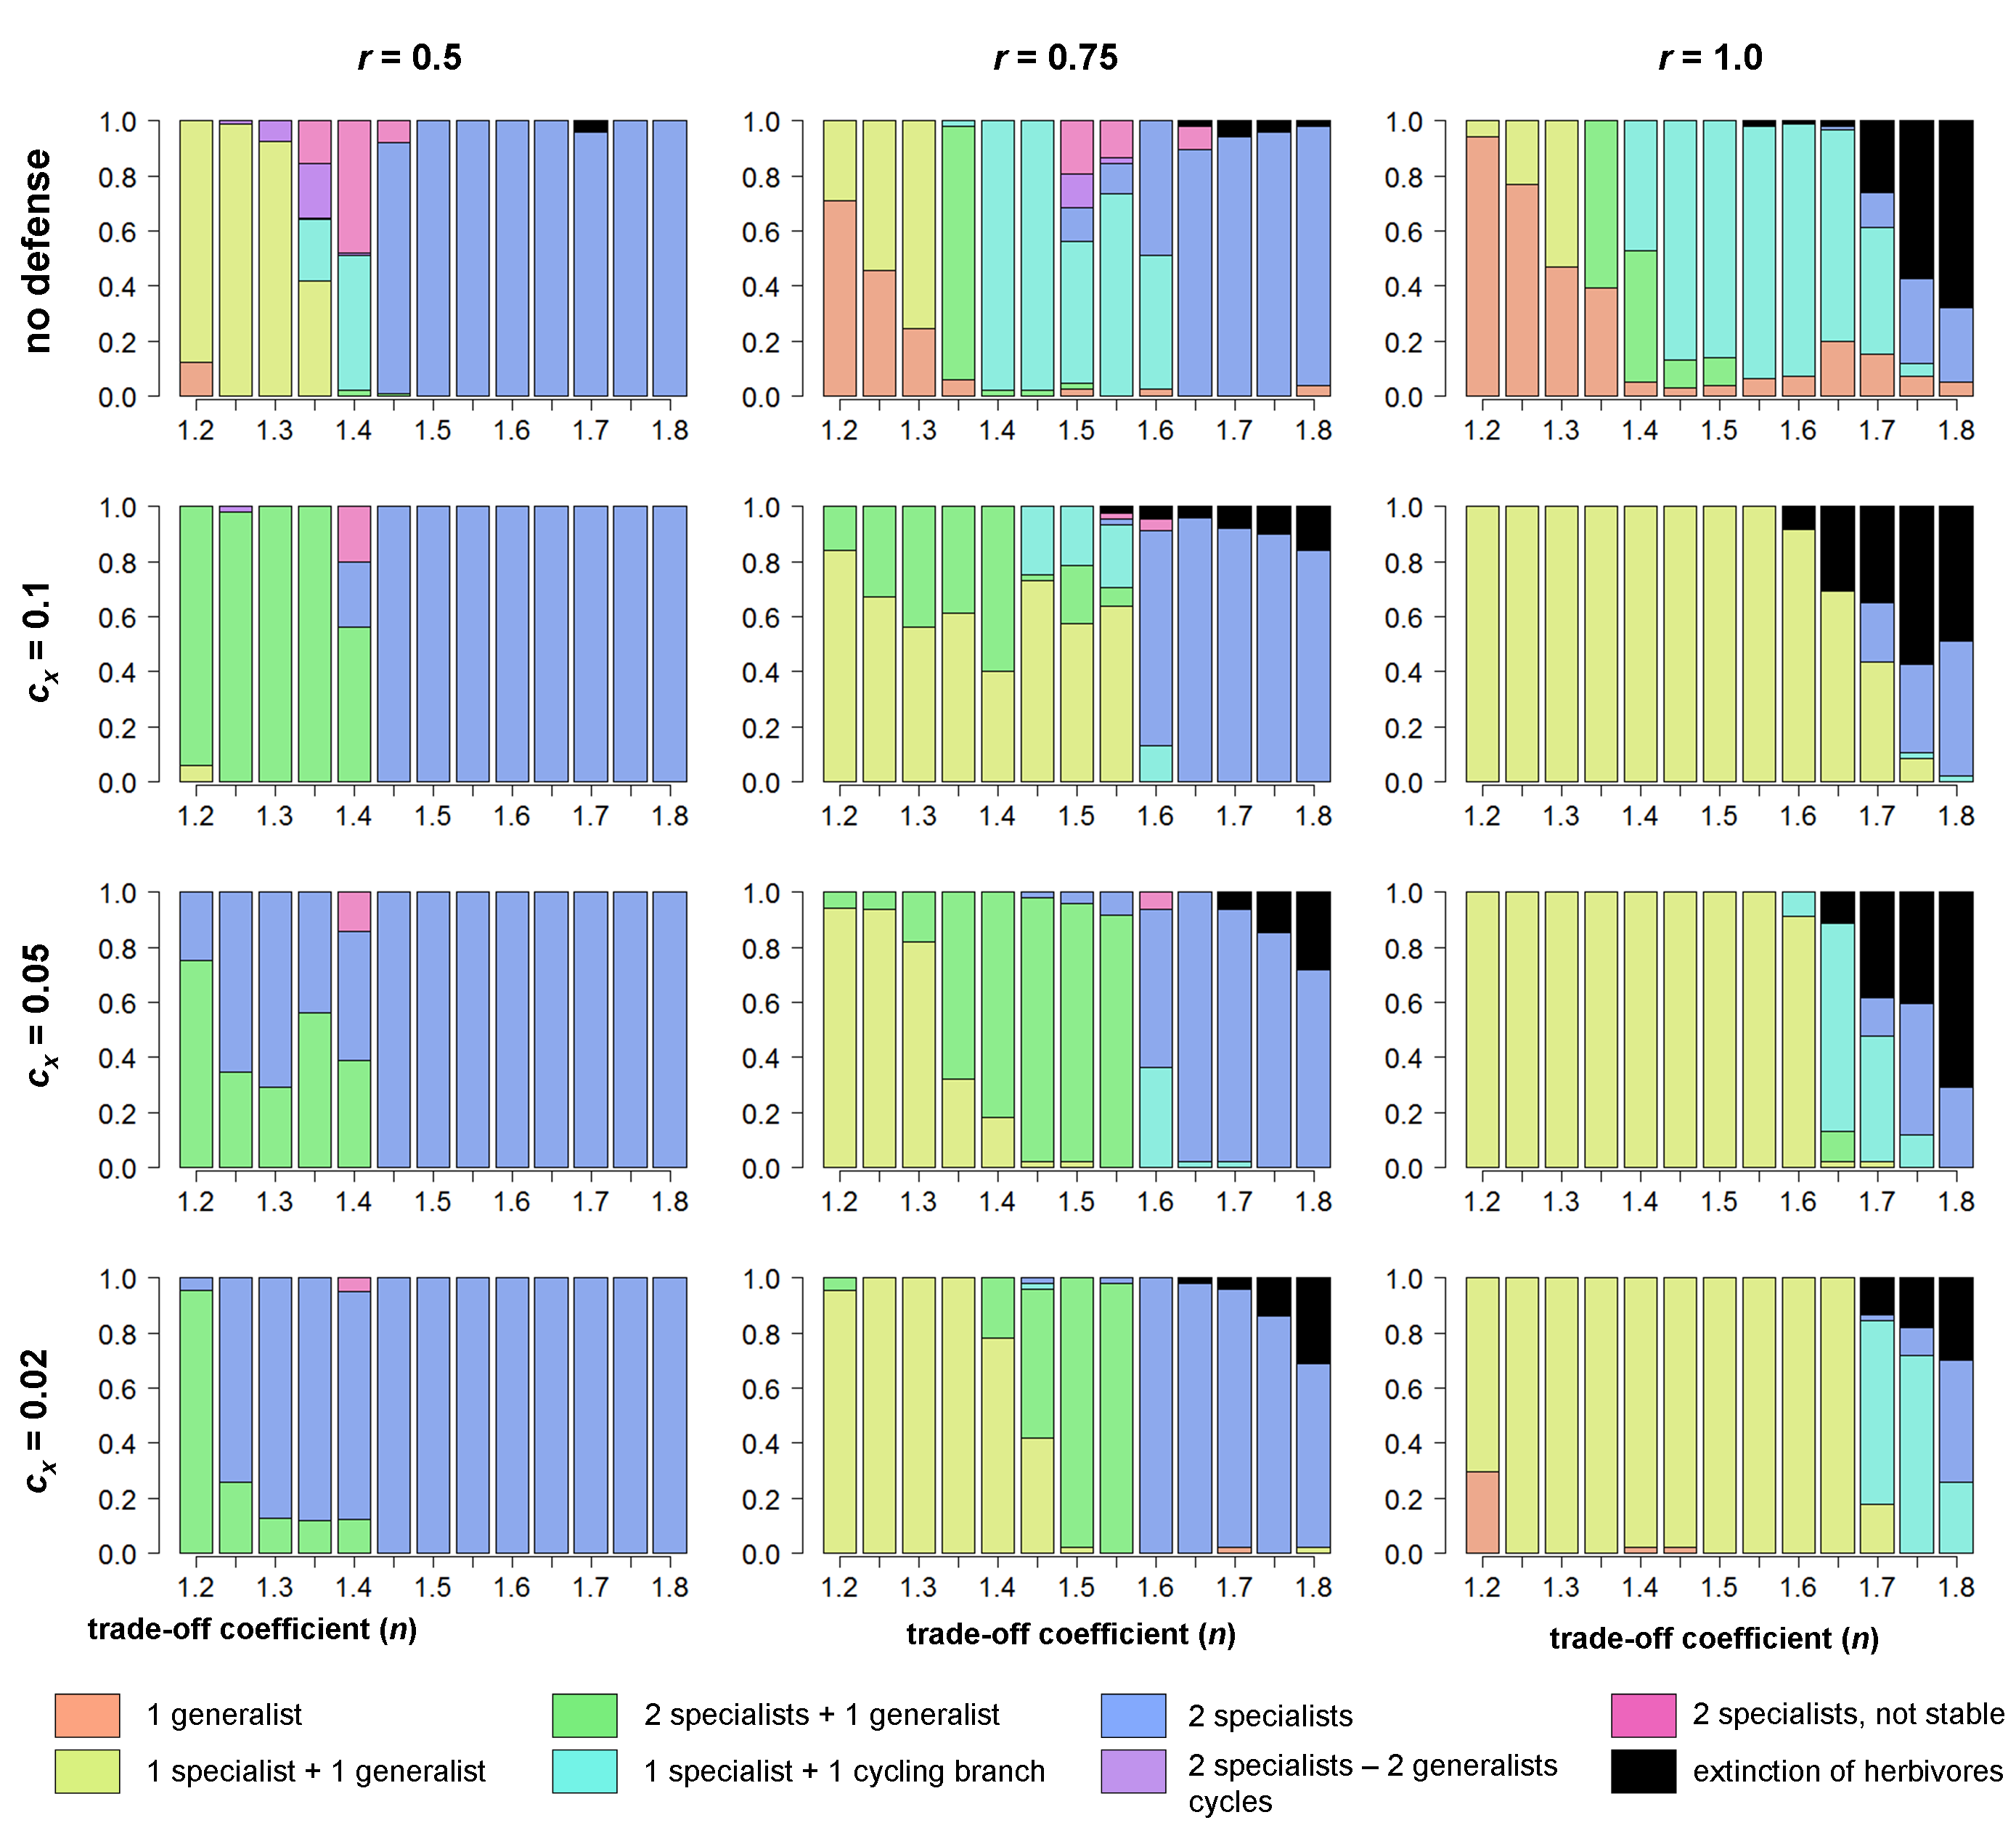
Figure 6.4. Herbivore outcomes for only herbivore evolution (top row) and plant-herbivore coevolution (bottom 3 rows). In all, T = 4.5∙10⁶, c_{P} = 1.0, c_{H} = 2.0, a = 10⁻⁵, t_{h} = 0.1, e = 0.25, d_{P} = 0.05, d_{H} = 0.4. Herbivore mutation step size = 0.01, mutation rate = 0.02; plant mutation step size = 0.001; number of time steps = 200,000. Efficiency of defense (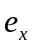) = 1.0.

Plant evolution and plant-herbivore coevolution
Looking at the results of plant evolution in response to herbivores, several patterns are immediately apparent. Most importantly, while the type of cost of defense used in this model (direct cost, lower growth rate) never leads to coexistence of different defense strategies when defending against a single type of herbivore (either generalist or specialist), evolutionary divergence can happen when defense co-evolves with herbivore specialization (Figure 6.5, 6.6). The initial evolutionary response of the two plants, before the herbivores have evolved a significant degree of specialization, is always the same (Figure 6.6); but subsequent herbivore evolution in turn affects plant evolution in such a way that coexistence of different strategies is possible. In fact, coexistence of an undefended and a well-defended plant is overall the most common outcome of plant evolution (Figure 6.5).
The feedback between herbivore and plant evolution is apparent in several ways. The severity of the trade-off for the herbivore is a major determining factor in how plant defense evolves, with higher levels of defense for weaker trade-offs (Figure 6.5). This appears mostly a factor of the types of herbivores that evolve for a given trade-off. In general, defense always evolves to nonzero values except in the case of complete herbivore specialization, in which case a no-defense strategy for both plants is common (Figure 6.5; see Figure 6.6f). Conversely, the highest levels of defense evolve against generalists (the few simulation runs in which herbivores evolve into a single generalist, both plants evolve high defense, and high + medium defense is associated exclusively with 1 specialist + 1 generalist herbivore).
To give a more detailed look at plant-herbivore coevolution, Figure 6.6 shows the results of individual simulation runs for part of the parameter range (r = 0.75, 1.4 ≤ n ≤ 1.6). There is a clear interaction between the evolutionary outcomes for herbivores and plants, but also between these and the herbivore trade-off strength n. For example, for lower values of n, the 2-specialist 1-generalist is associated with a combination of high / low defense; whereas for a stronger trade-off (n = 1.5), this combination of herbivore strategies is always associated with two weakly-defended plants (Figure 6.6c, 6.6d).
Whether herbivore evolution mostly drives plant evolution or vice versa is difficult to determine with just these results. As an example, in the case of 1 generalist + 1 specialist herbivore, the two plants suffer different levels of herbivory, leading to divergence in their investment into defense. However, the interaction can go either way. First, the plant suffering more from herbivory can evolve higher defense, as would be expected from models on plant defense (Fagerstrom et al. 1987; Ito and Sakai 2009; Krzysztof Janczur 2009). On the other hand, if one plant evolves a higher level of defense, it makes sense for herbivores to avoid that plant. The well-defended plant can be either the most-consumed or the least-consumed one, depending on the way this interaction goes; and both of these patterns are indeed found (compare Figure 6.6a to 6.6b).
While these results already suggest some interesting interactions between plant evolution, herbivore evolution and their ecological dynamics, it barely scratches the surface of the subject. The parameter range studied is very narrow; in addition, I assumed a direct trade-off for plant defense, while a different trade-off may lead to very different results (see Chapter 3). Ideally, plant evolution would be simulated in the same way that herbivore evolution is (i.e. starting with a single plant and allowing evolutionary branching and/or extinction), potentially allowing complex plant-herbivore communities with any number of species to evolve from a single plant and herbivore. Evolution of herbivore preference may strongly depend on the number of plant species present (see section 6.2), increasing the potential complexity of eco-evolutionary feedbacks in such a model.
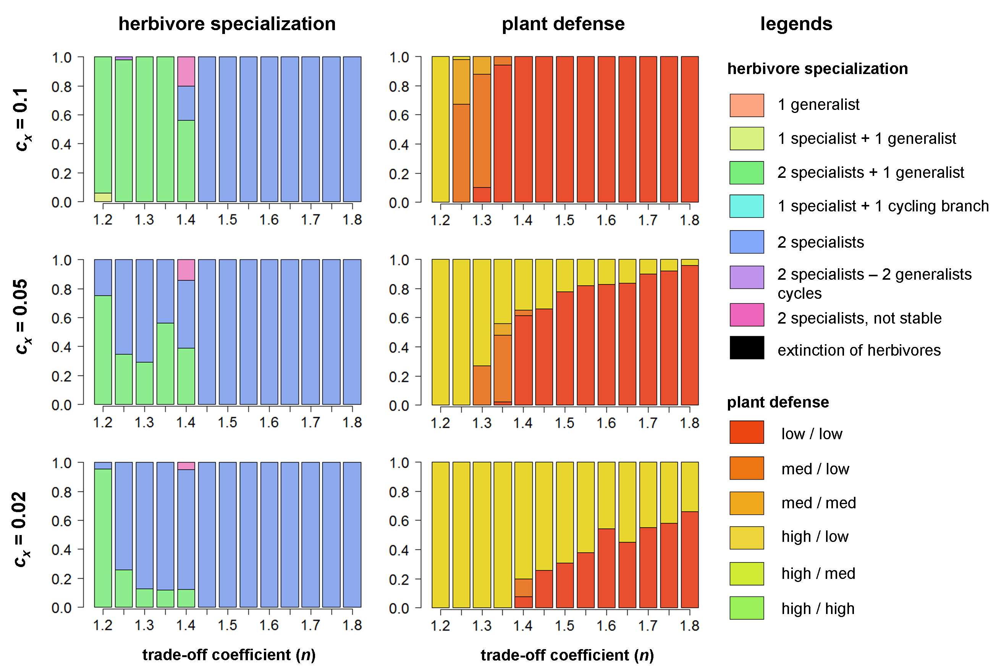
Figure 6.5 Evolution of herbivore specialization (left) and plant defense (right) for r = 0.5; all other parameters the same as in Figure 6.4. Level of defense for both plants was recorded at the end of each simulation run and categorized into low / no defense (defense < 0.1), medium (0.1 ≤ defense ≤ 0.4) and high (defense > 0.4).

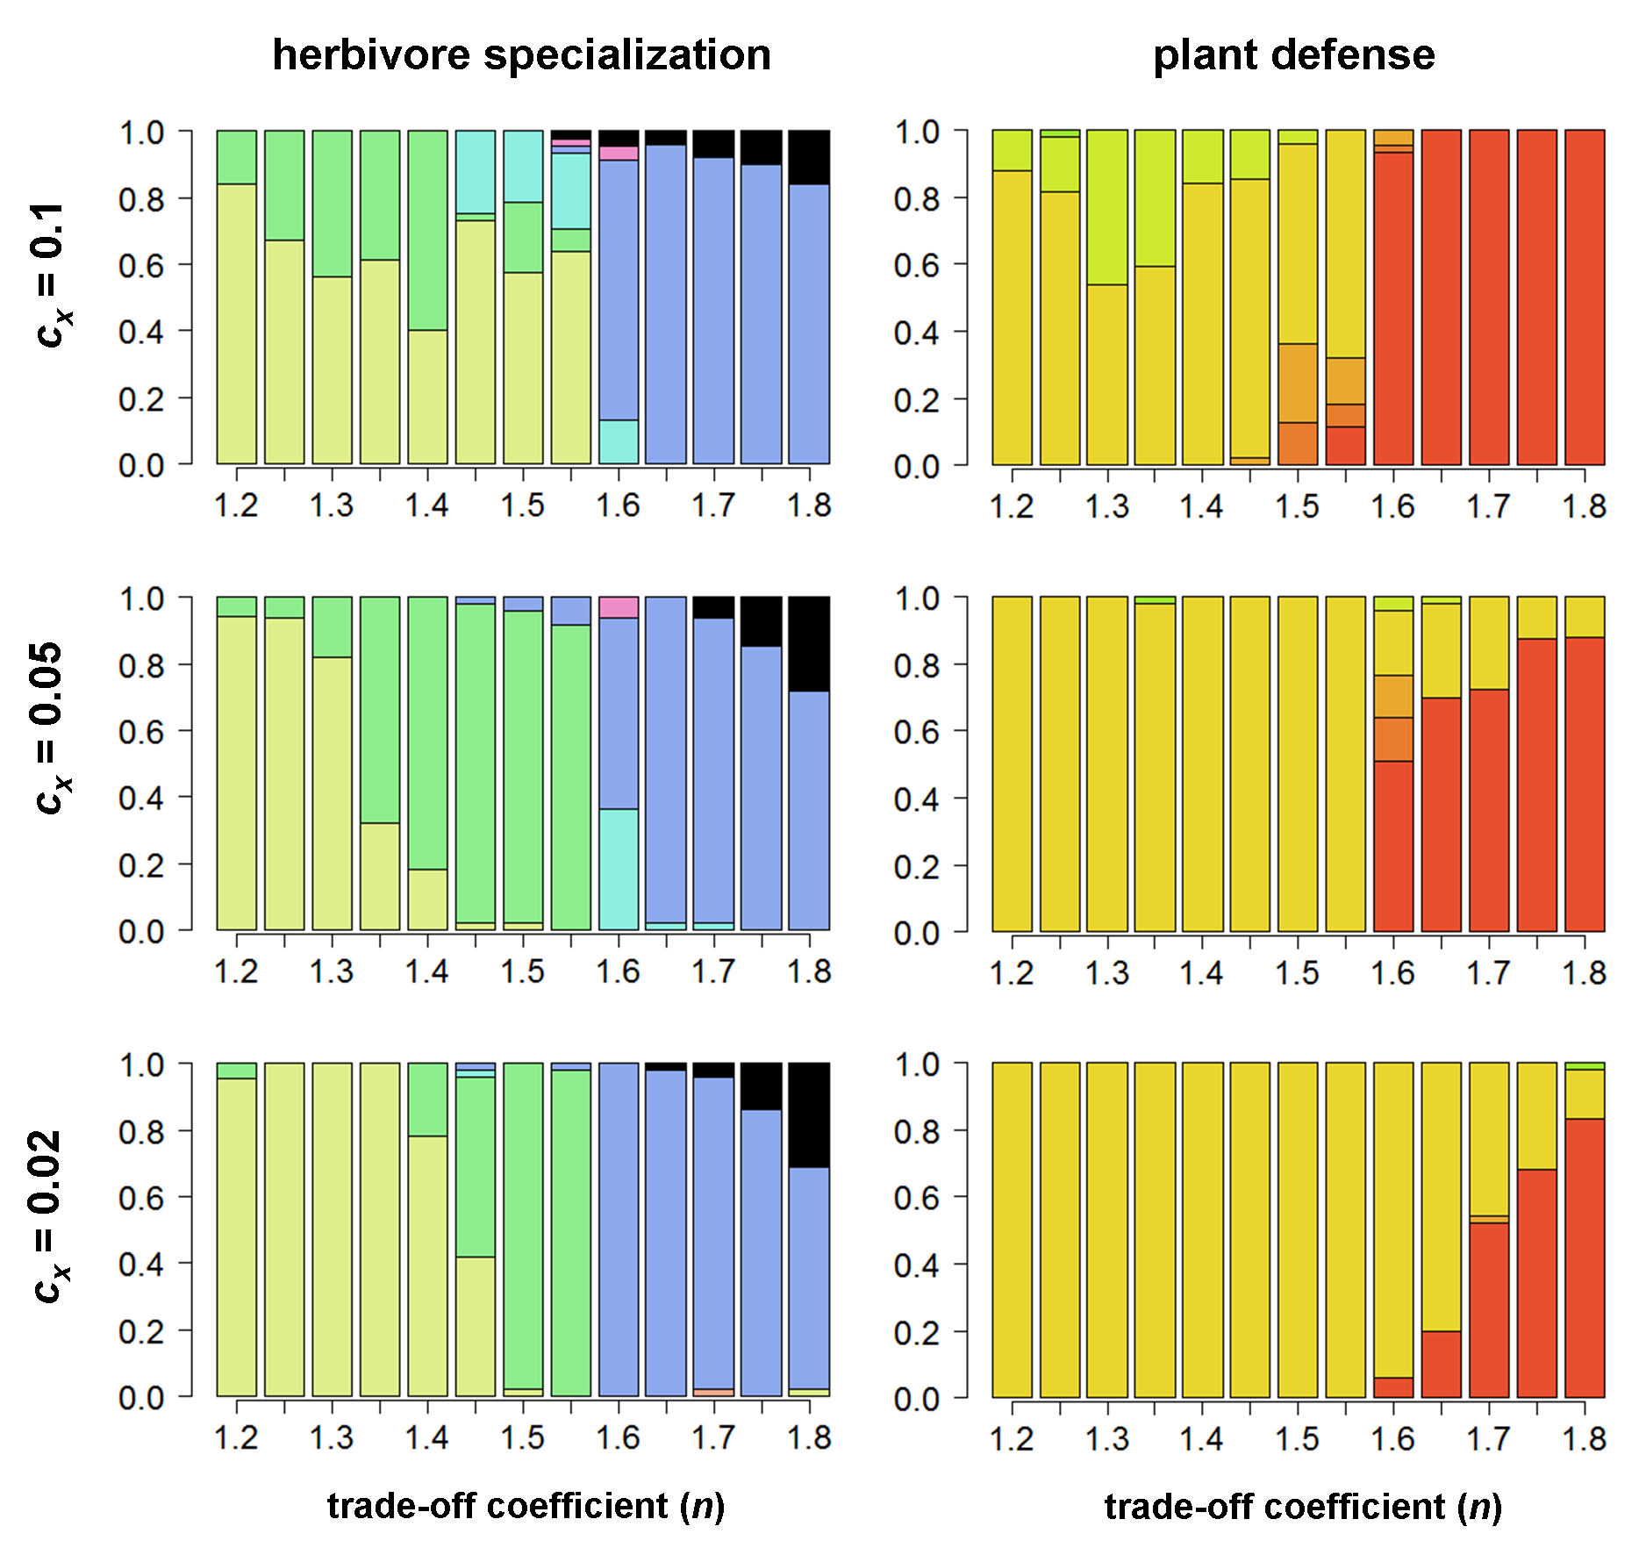
Figure 6.5 (cont.) Evolution of herbivore specialization (left) and plant defense (right) for r = 0.75.

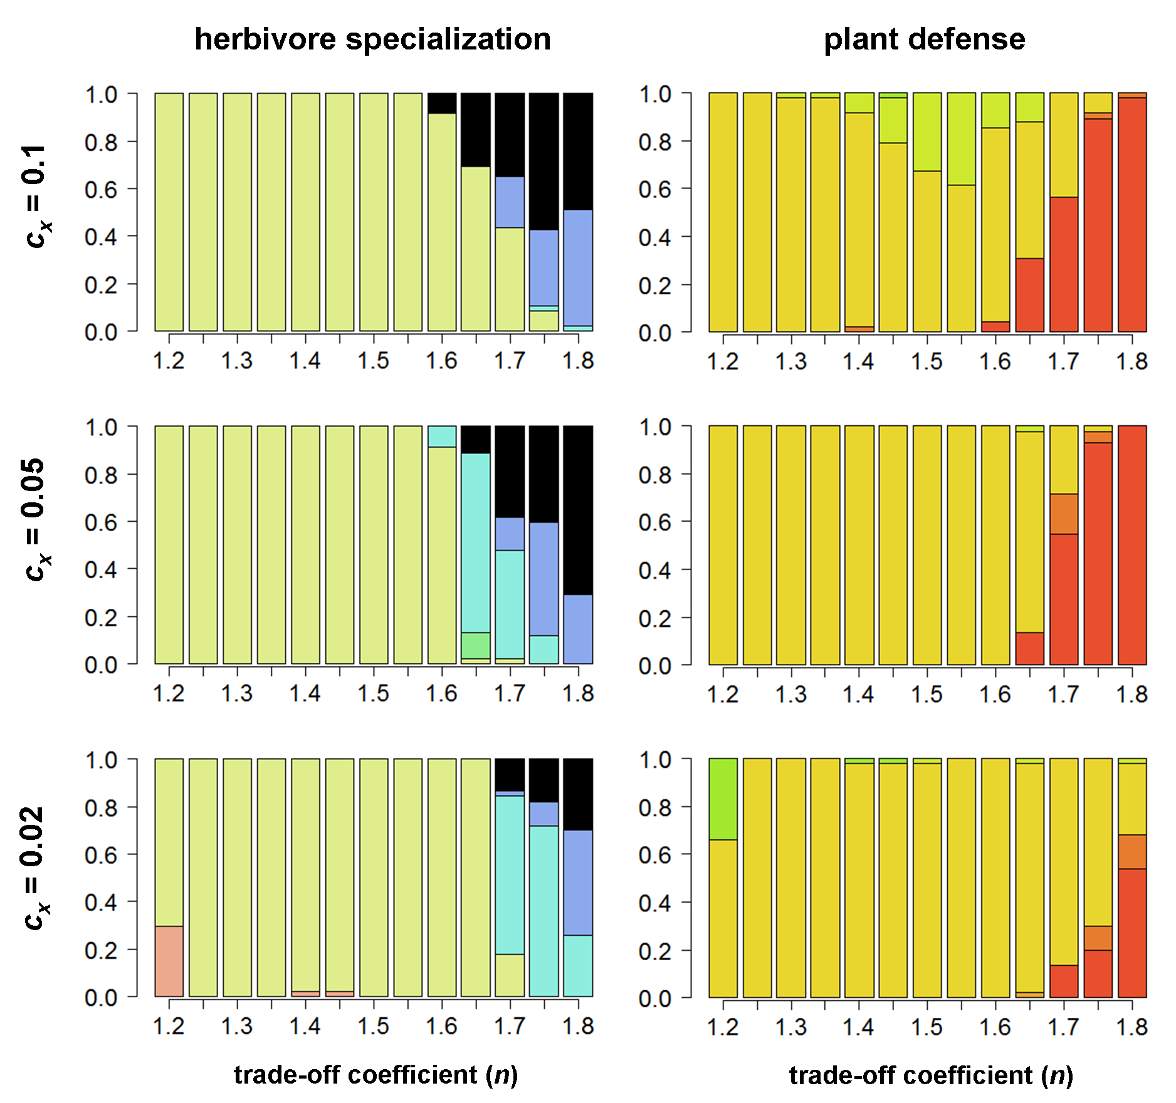
Figure 6.5 (cont.) Evolution of herbivore specialization (left) and plant defense (right) for r = 1.0.

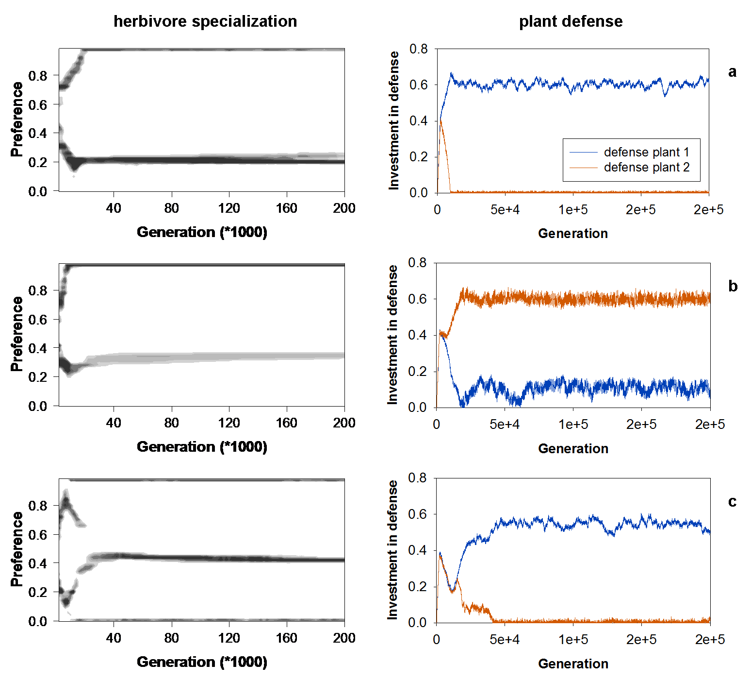
Figure 6.6. Examples of individual simulation runs showing the different co-evolutionary scenarios found for the parameters r = 0.75, 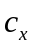 = 0.1, . (a) n = 1.4: 1 generalist + 1 specialist; 1 well-defended and 1 undefended plant, with the most attacked plant evolving high defense. (b) n = 1.4: 1 generalist + 1 specialist; 1 well-defended and 1 poorly-defended plant, with the least attacked plant evolving high defense. (c) n = 1.4: 1 generalist + 2 specialists; 1 well-defended and 1 undefended plant.

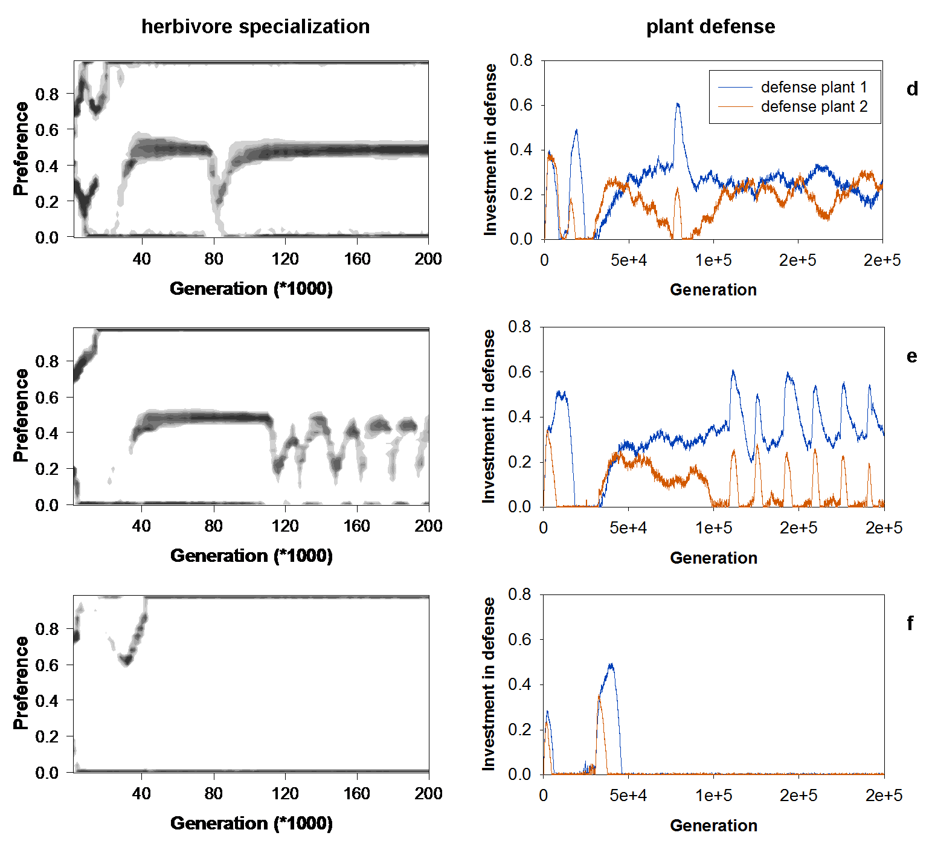
Figure 6.6 (cont.) (d) n = 1.5: 1 generalist + 2 specialists; both plants evolve the same intermediate level of defense. (e) n = 1.5: 1 specialist + branching/extinction cycles in the other herbivore; cycling in plant defense, with both plant species evolving higher defense as branching occurs and evolving lower defense as the specialist on plant 2 goes extinct. (f) n = 1.6: 2 specialists; both plants evolve no defense.

References
References
Abrams, P. A. 2006a. Adaptive change in the resource-exploitation traits of a generalist consumer: The evolution and coexistence of generalists and specialists. Evolution 60:427-439.
Abrams, P. A. 2006b. The prerequisites for and likelihood of generalist-specialist coexistence. American Naturalist 167:329-342.
Abrams, P. A. 2000. Character shifts of prey species that share predators. American Naturalist 156:S45-S61.
Abrams, P. A., and X. Chen. 2002. The effect of competition between prey species on the evolution of their vulnerabilities to a shared predator. Evolutionary Ecology Research 4:897-909.
Abrams, P. A., and H. Matsuda. 1997. Prey adaptation as a cause of predator-prey cycles. Evolution 51:1742-1750.
Abrams, P., and X. Chen. 2002. The evolution of traits affecting resource acquisition and predator vulnerability: Character displacement under real and apparent competition. American Naturalist 160:692-704.
Bassar, R. D., M. C. Marshall, A. Lopez-Sepulcre, E. Zandona, S. K. Auer, J. Travis, C. M. Pringle, A. S. Flecker, S. A. Thomas, D. F. Fraser, and D. N. Reznick. 2010. Local adaptation in Trinidadian guppies alters ecosystem processes. Proceedings of the National Academy of Sciences of the United States of America 107:3616-3621.
Bowers, R. G., and D. E. Hodgkinson. 2001. Community dynamics, trade-offs, invasion criteria and the evolution of host resistance to microparasites. Journal of theoretical biology 212:315-331.
Bronstein, J. L. 2009. The evolution of facilitation and mutualism. Journal of Ecology 97:1160-1170.
Carroll, S. P., A. P. Hendry, D. N. Reznick, and C. W. Fox. 2007. Evolution on ecological time-scales. Functional Ecology 21:387-393.
Egas, M., U. Dieckmann, and M. W. Sabelis. 2004. Evolution restricts the coexistence of specialists and generalists: The role of trade-off structure. American Naturalist 163:518-531.
Fagerstrom, T., S. Larsson, and O. Tenow. 1987. On optimal defence in plants. Functional Ecology 1:73-81.
Hairston, N. G., S. P. Ellner, M. A. Geber, T. Yoshida, and J. A. Fox. 2005. Rapid evolution and the convergence of ecological and evolutionary time. Ecology Letters 8:1114-1127.
Harmon, L. J., B. Matthews, S. Des Roches, J. M. Chase, J. B. Shurin, and D. Schluter. 2009. Evolutionary diversification in stickleback affects ecosystem functioning. Nature 458:1167-1170.
Hendry, A. P., P. Nosil, and L. H. Rieseberg. 2007. The speed of ecological speciation. Functional Ecology 21:455-464.
Ito, H. C., and U. Dieckmann. 2012. Evolutionary-branching lines and areas in bivariate trait spaces. Evolutionary Ecology Research 14:555-582.
Ito, K., and S. Sakai. 2009. Optimal defense strategy against herbivory in plants: conditions selecting for induced defense, constitutive defense, and no-defense. Journal of theoretical biology 260:453-459.
Johnson, M. T. J., and J. R. Stinchcombe. 2007. An emerging synthesis between community ecology and evolutionary biology. Trends in Ecology & Evolution 22:250-257.
Kisdi, E. 2002. Dispersal: Risk spreading versus local adaptation. American Naturalist 159:579-596.
Kokko, H., and A. Lopez-Sepulcre. 2007. The ecogenetic link between demography and evolution: can we bridge the gap between theory and data? Ecology Letters 10:773-782.
Kremer, C. T., and C. A. Klausmeier. 2013. Coexistence in a variable environment: Eco-evolutionary perspectives. Journal of theoretical biology 339:14-25.
Krzysztof Janczur, M. 2009. Optimal energy allocation to growth, reproduction, and production of defensive substances in plants: a model. Evolutionary Ecology Research 11:447-470.
Lankau, R. A. 2011. Rapid evolutionary change and the coexistence of species. Annual Review of Ecology, Evolution, and Systematics, Vol 42 42:335-354.
Levins, R. 1962. Theory of fitness in a heterogeneous environment 1: Fitness set and adaptive function. American Naturalist 96:361-373.
Loeuille, N., and M. Loreau. 2004. Nutrient enrichment and food chains: can evolution buffer top-down control? Theoretical population biology 65:285-298.
McIntire, E. J. B., and A. Fajardo. 2014. Facilitation as a ubiquitous driver of biodiversity. New Phytologist 201:403-416.
Palkovacs, E. P., M. C. Marshall, B. A. Lamphere, B. R. Lynch, D. J. Weese, D. F. Fraser, D. N. Reznick, C. M. Pringle, and M. T. Kinnison. 2009. Experimental evaluation of evolution and coevolution as agents of ecosystem change in Trinidadian streams. Philosophical Transactions of the Royal Society B-Biological Sciences 364:1617-1628.
Pelletier, F., D. Garant, and A. P. Hendry. 2009. Eco-evolutionary dynamics. Philosophical Transactions of the Royal Society B-Biological Sciences 364:1483-1489.
Post, D. M., and E. P. Palkovacs. 2009. Eco-evolutionary feedbacks in community and ecosystem ecology: interactions between the ecological theatre and the evolutionary play. Philosophical Transactions of the Royal Society B-Biological Sciences 364:1629-1640.
Rueffler, C., T. J. M. Van Dooren, and J. A. J. Metz. 2007. The interplay between behavior and morphology in the evolutionary dynamics of resource specialization. American Naturalist 169:E34-E52.
Sagitov, S., B. Mehlig, P. Jagers, and V. Vatutin. 2013. Evolutionary branching in a stochastic population model with discrete mutational steps. Theoretical population biology 83:145-154.
Schoener, T. W. 2011. The newest synthesis: understanding the interplay of evolutionary and ecological dynamics. Science 331:426-429.
Seehausen, O. 2009. Speciation affects ecosystems. Nature 458:1122-1123.
Strauss, S. Y., J. A. Rudgers, J. A. Lau, and R. E. Irwin. 2002. Direct and ecological costs of resistance to herbivory. Trends in Ecology & Evolution 17:278-285.
terHorst, C. P., T. E. Miller, and E. Powell. 2010. When can competition for resources lead to ecological equivalence? Evolutionary Ecology Research 12:843-854.
Vage, S., J. E. Storesund, J. Giske, and T. F. Thingstad. 2014. Optimal defense strategies in an idealized microbial food web under trade-off between competition and defense. Plos One 9:e101415.
Vasseur, D. A., P. Amarasekare, V. H. W. Rudolf, and J. M. Levine. 2011. Eco-evolutionary dynamics enable coexistence via neighbor-dependent selection. American Naturalist 178:E96-E109.
Yamamichi, M., T. Yoshida, and A. Sasaki. 2011. Comparing the effects of rapid evolution and phenotypic plasticity on predator-prey dynamics. American Naturalist 178:287-304.
Yoshida, T., L. E. Jones, S. P. Ellner, G. F. Fussmann, and N. G. Hairston. 2003. Rapid evolution drives ecological dynamics in a predator-prey system. Nature 424:303-306.
Yoshida, T., S. P. Ellner, L. E. Jones, B. J. M. Bohannan, R. E. Lenski, and N. G. Hairston Jr. 2007. Cryptic population dynamics: Rapid evolution masks trophic interactions. Plos Biology 5:1868-1879.

